1. Welcome Message API

Problem Statement: Create a REST API that returns a welcome message from the service layer.

Logic: Service returns "Welcome to Spring Boot REST API"

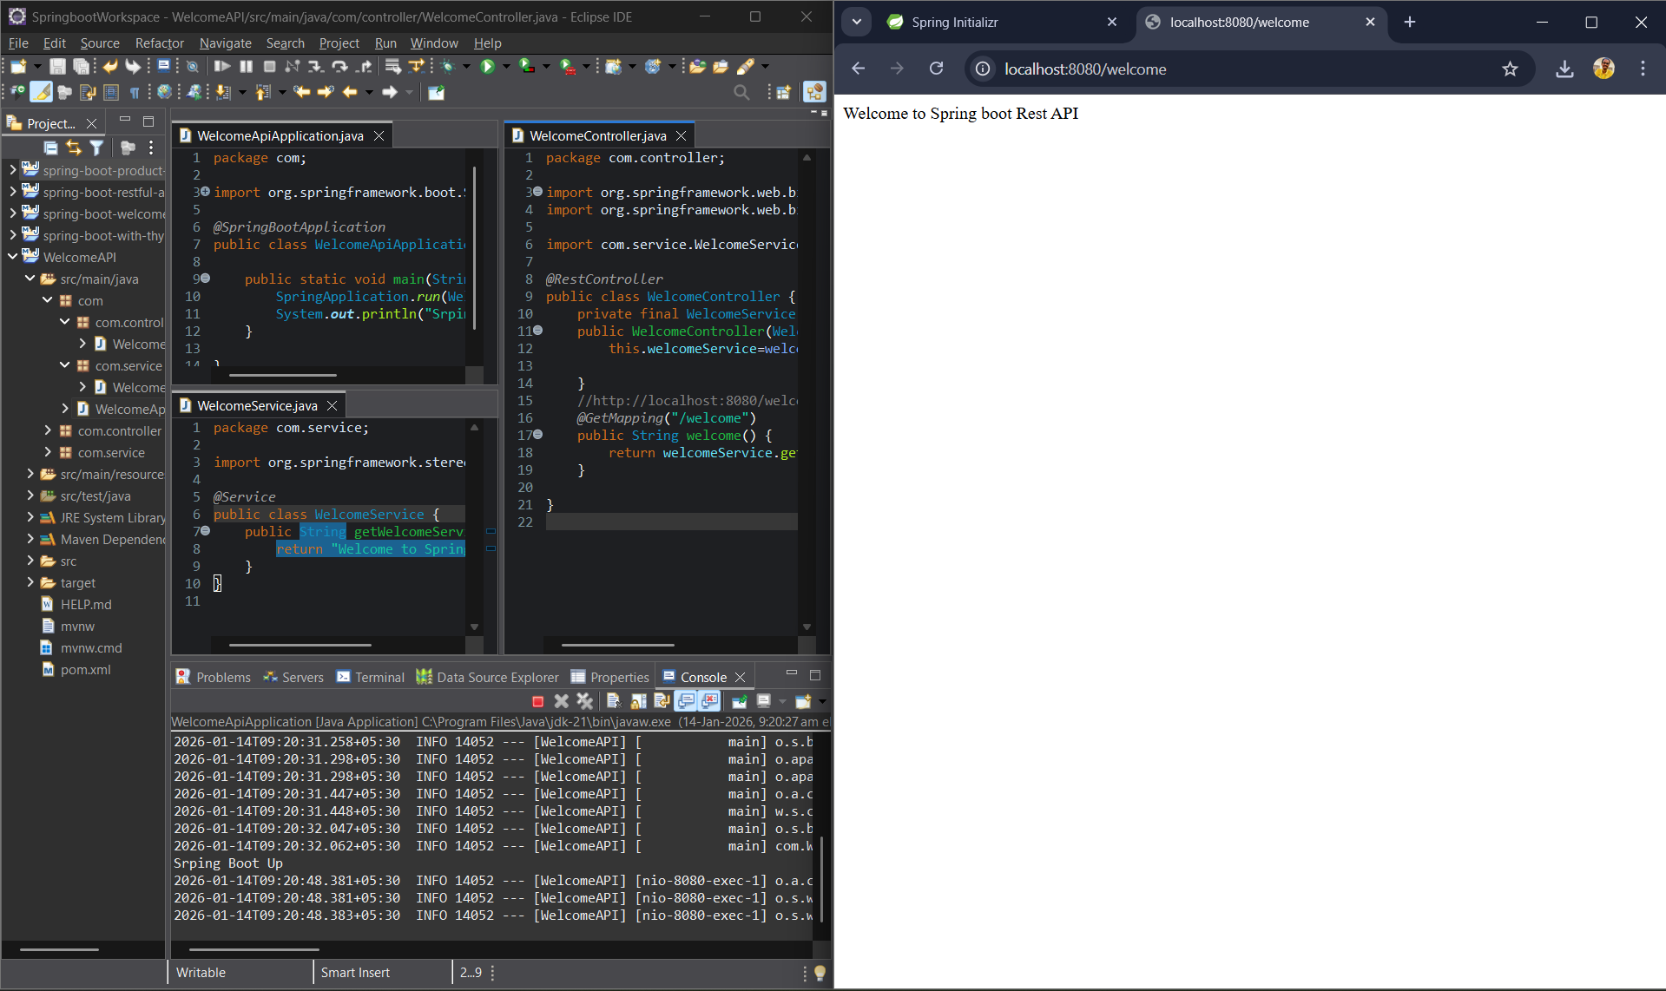

2. Simple Calculator - Addition

Problem Statement: Create an API to add two numbers.

Logic: Service performs addition and returns result.

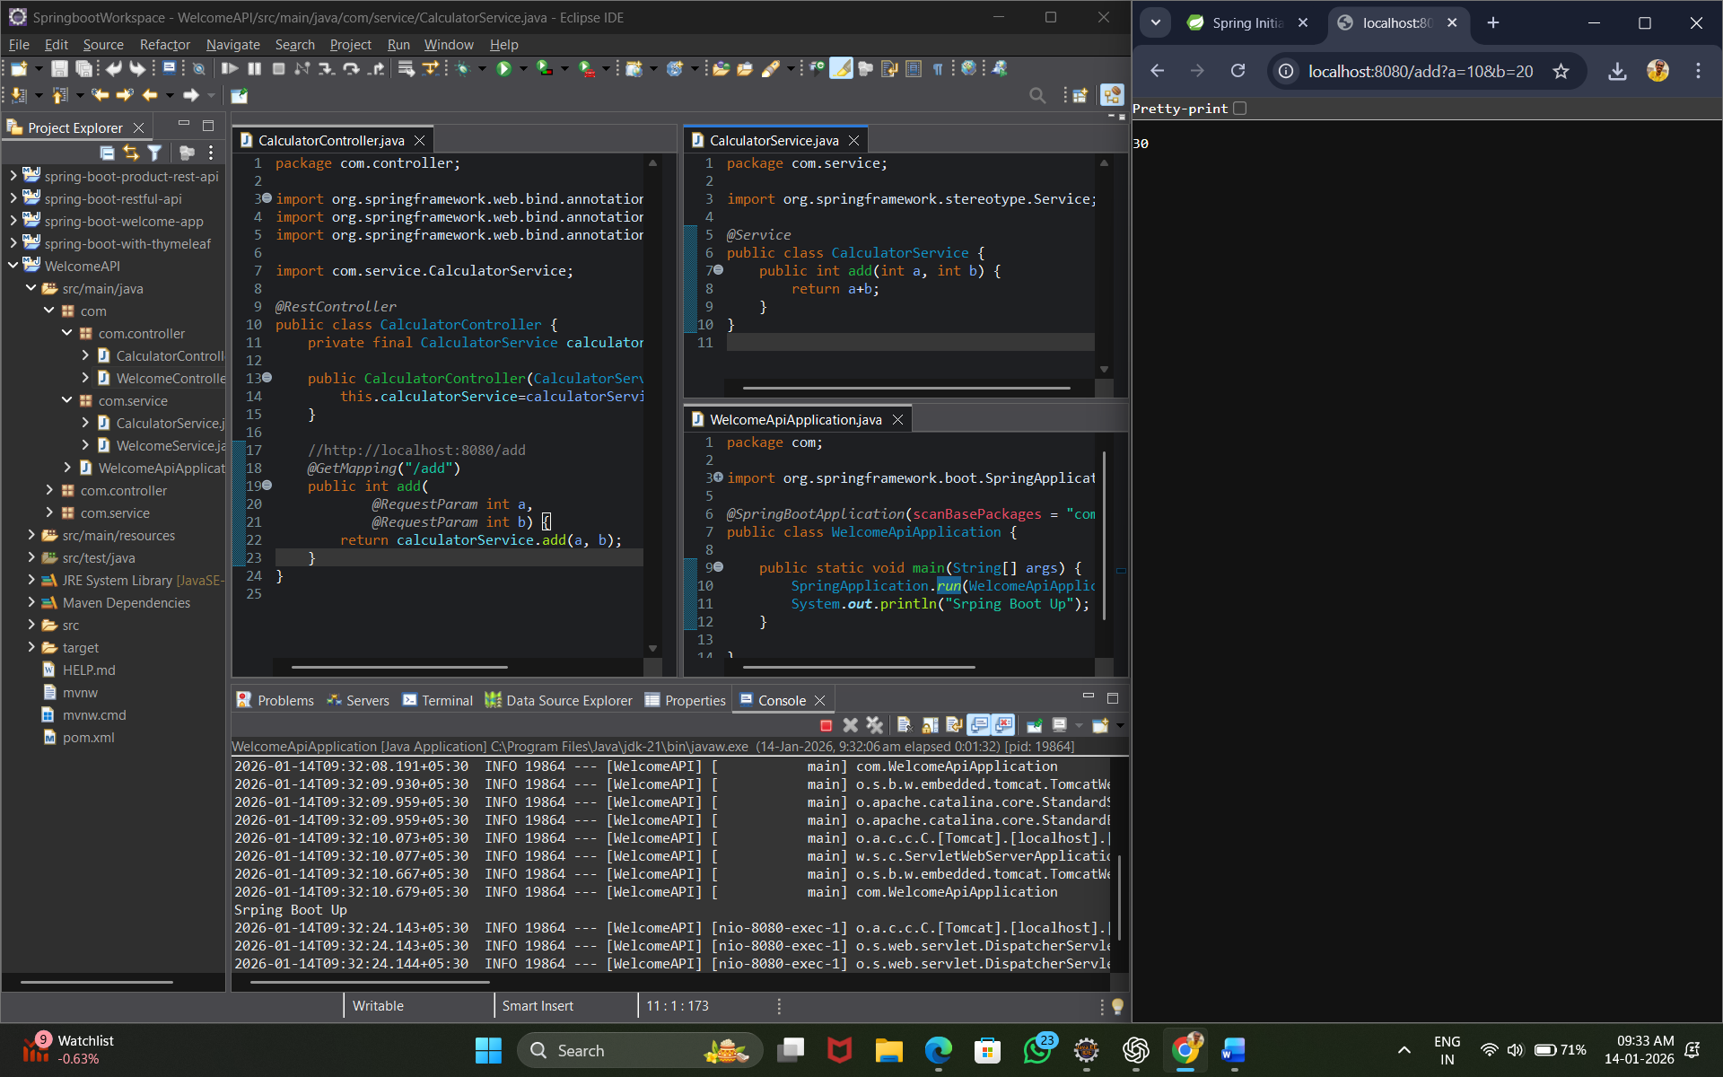

3. Simple Calculator - Even or Odd

Problem Statement: Check whether a given number is even or odd.

Logic: Service checks num % 2.

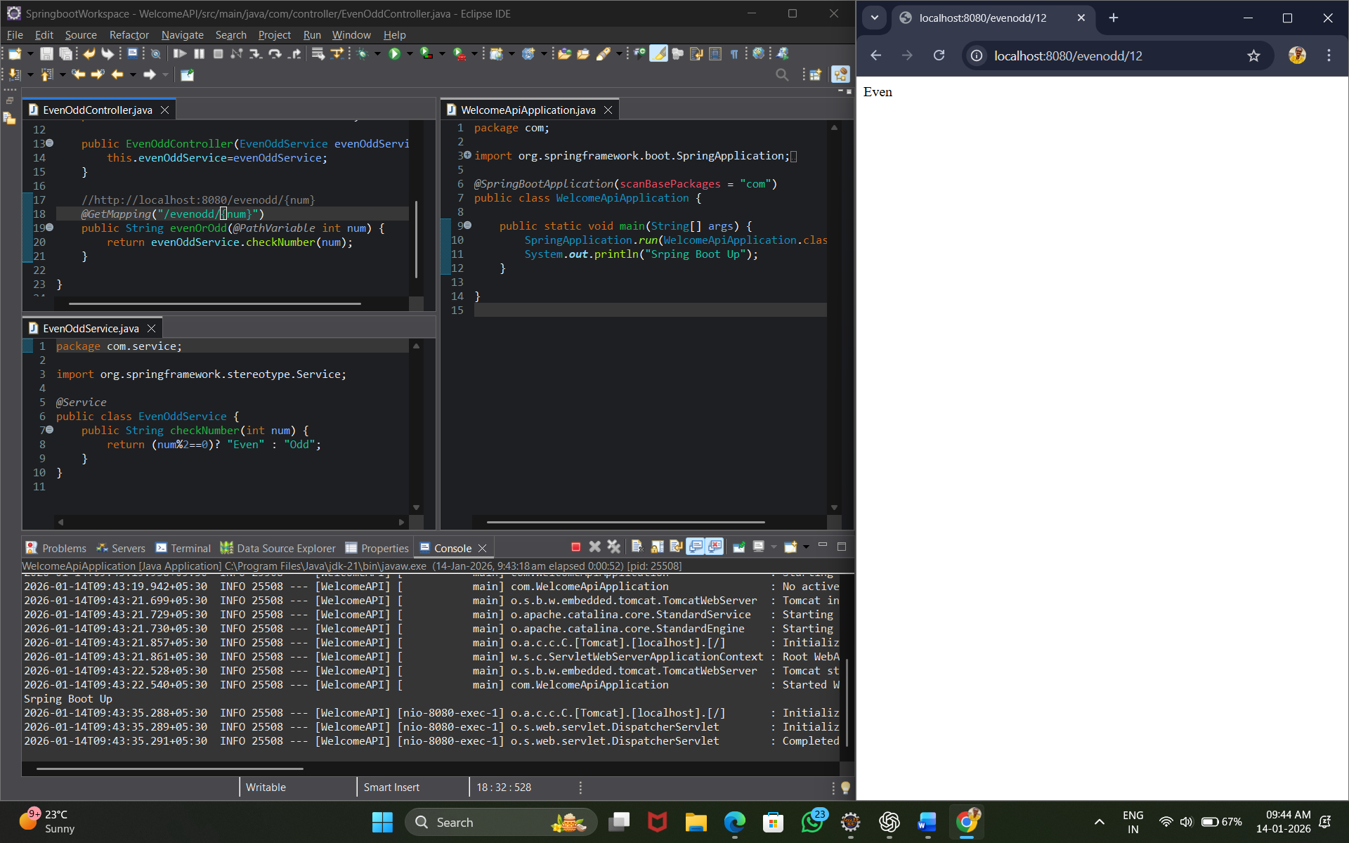

4. Age Category API

Problem Statement: Determine age category: Child, Adult, or Senior Citizen.

Logic:. <18 > Child 18-59 > Adult ≥60 > Senior

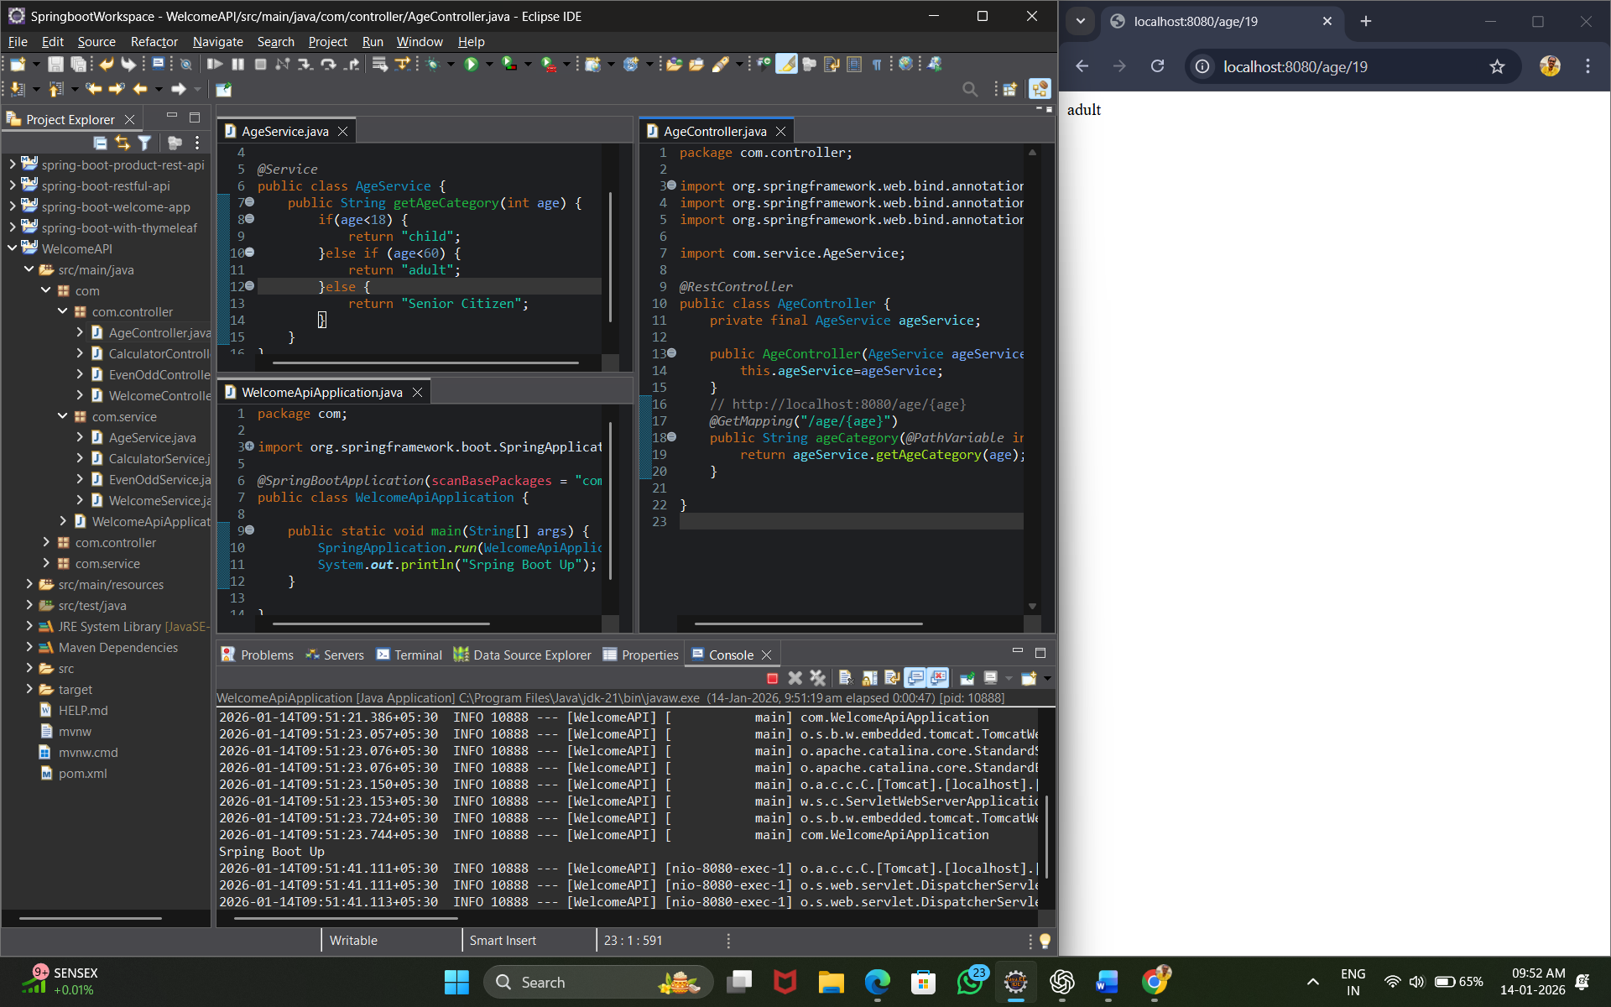

5. Grade Calculation API

Problem Statement: Calculate grade based on marks.

Logic: ≥90 > A ≥75> B ≥60 >C else > Fail

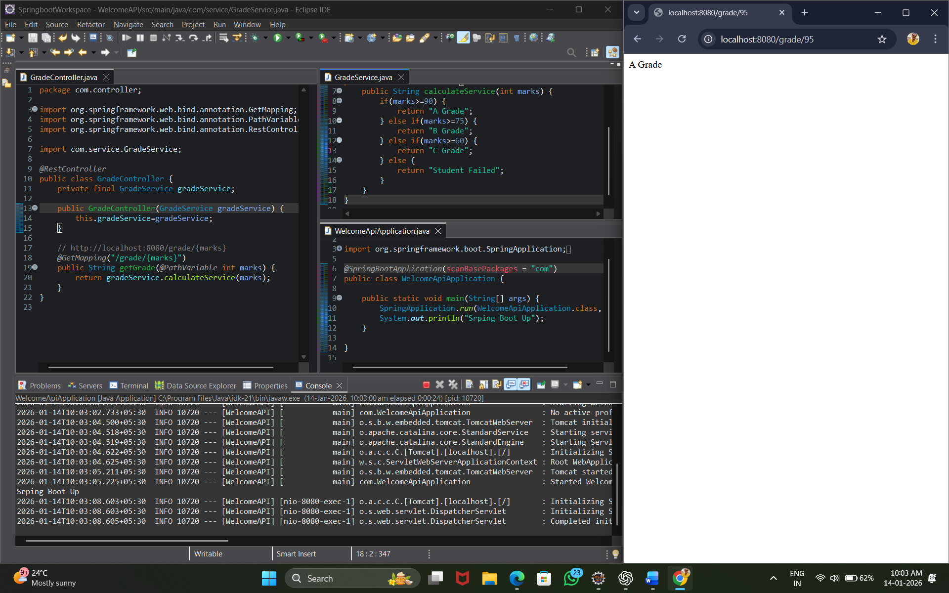

6. Temperature Conversion API

Problem Statement: Convert Celsius to Fahrenheit.

Logic: (celsius \* 9/5) + 32

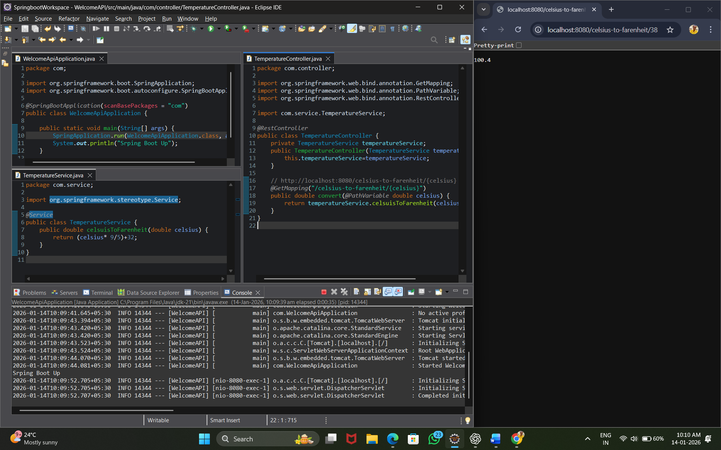

7. String Reverse API

Problem Statement: Reverse a given string.

Logic: Use StringBuilder.reverse().

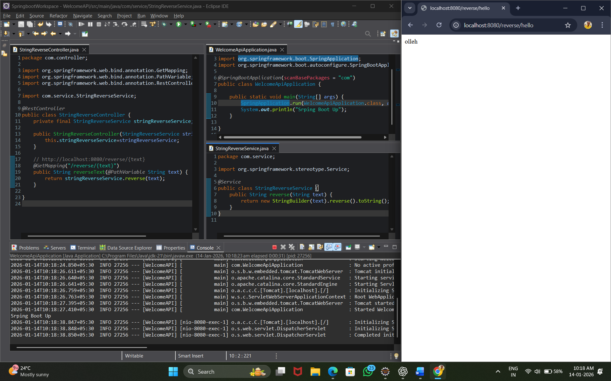

8. Palindrome Check API

Problem Statement: Check whether a string is a palindrome.

Logic: Compare original and reversed string.

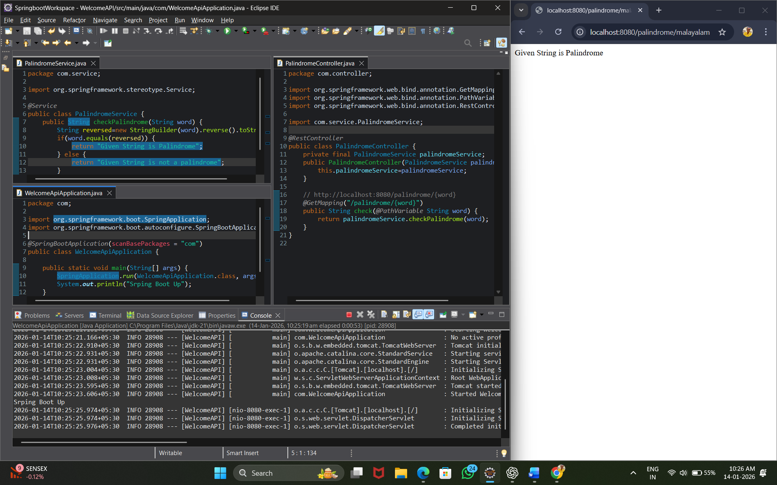

9. Factorial Calculation API

Problem Statement: Calculate factorial of a number.

Logic: Loop-based factorial calculation.

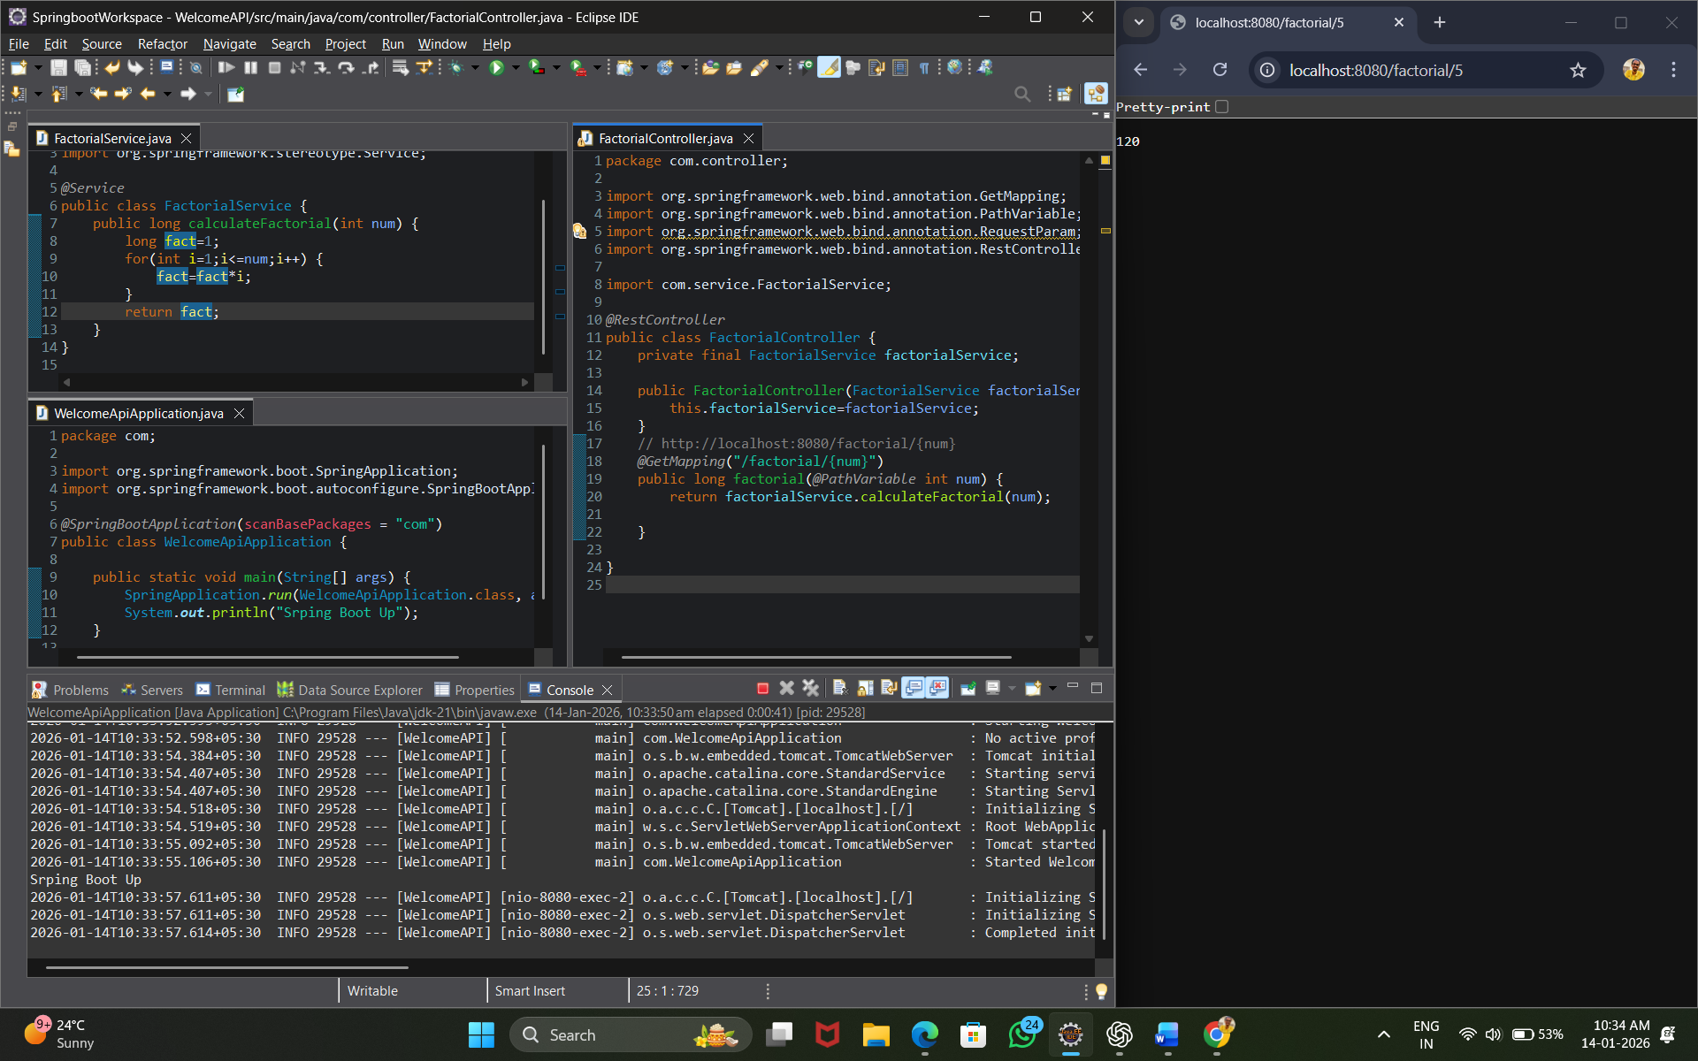

10. Prime Number Check API

Problem Statement: Check whether a number is prime.

Logic: Check divisibility up to Vn.

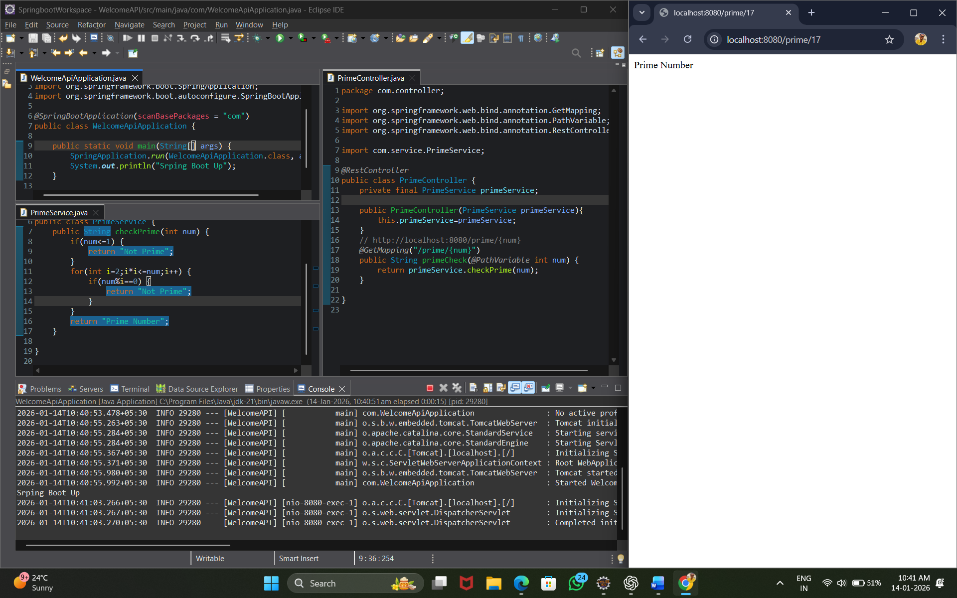

11. Discount Calculation API

Problem Statement: Calculate final price after discount.

Logic: price - (price \* discount / 100)

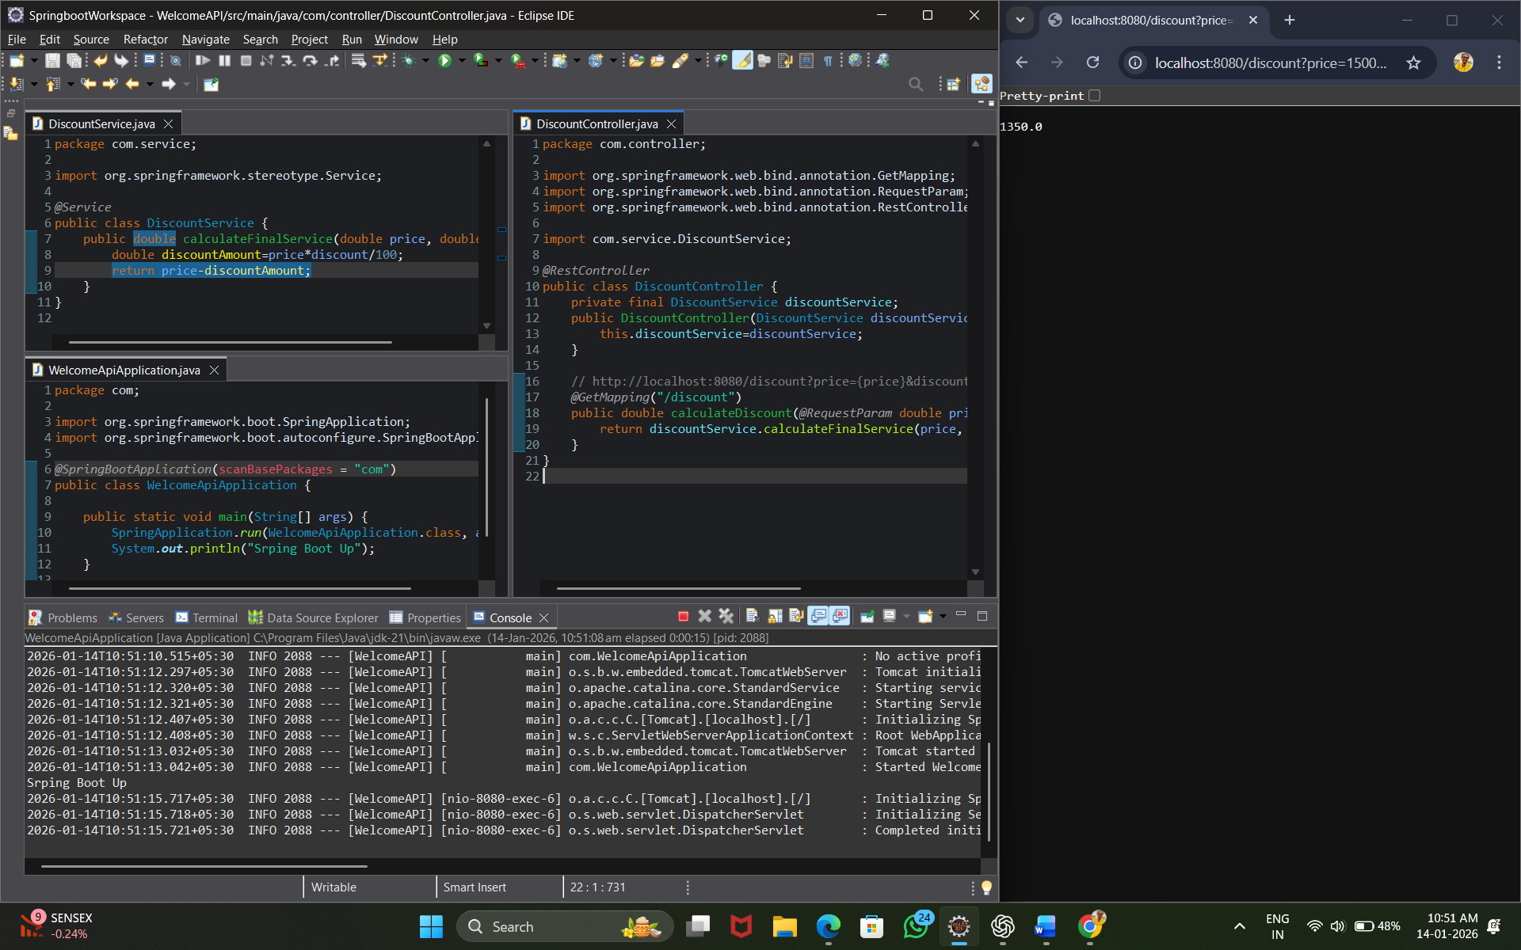

12. Login Validation API

Problem Statement: Validate username and password.

Logic: Username = admin Password = admin123 Return success or failure

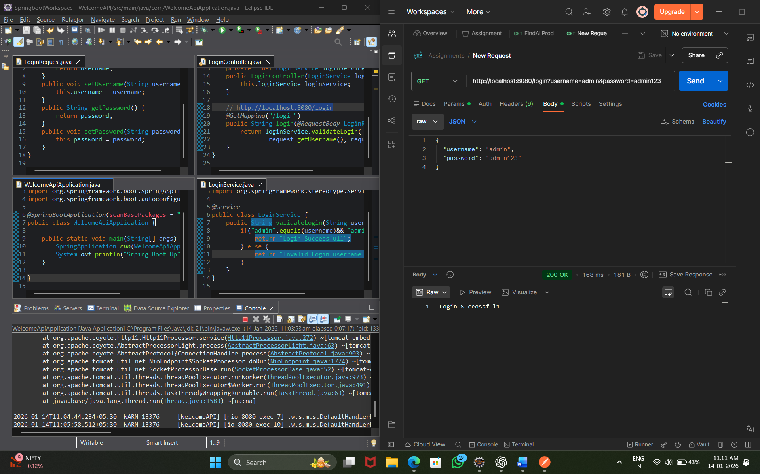

13. Simple Interest Calculator API

Problem Statement: Calculate simple interest.

Logic: (p\*r\*t) / 100

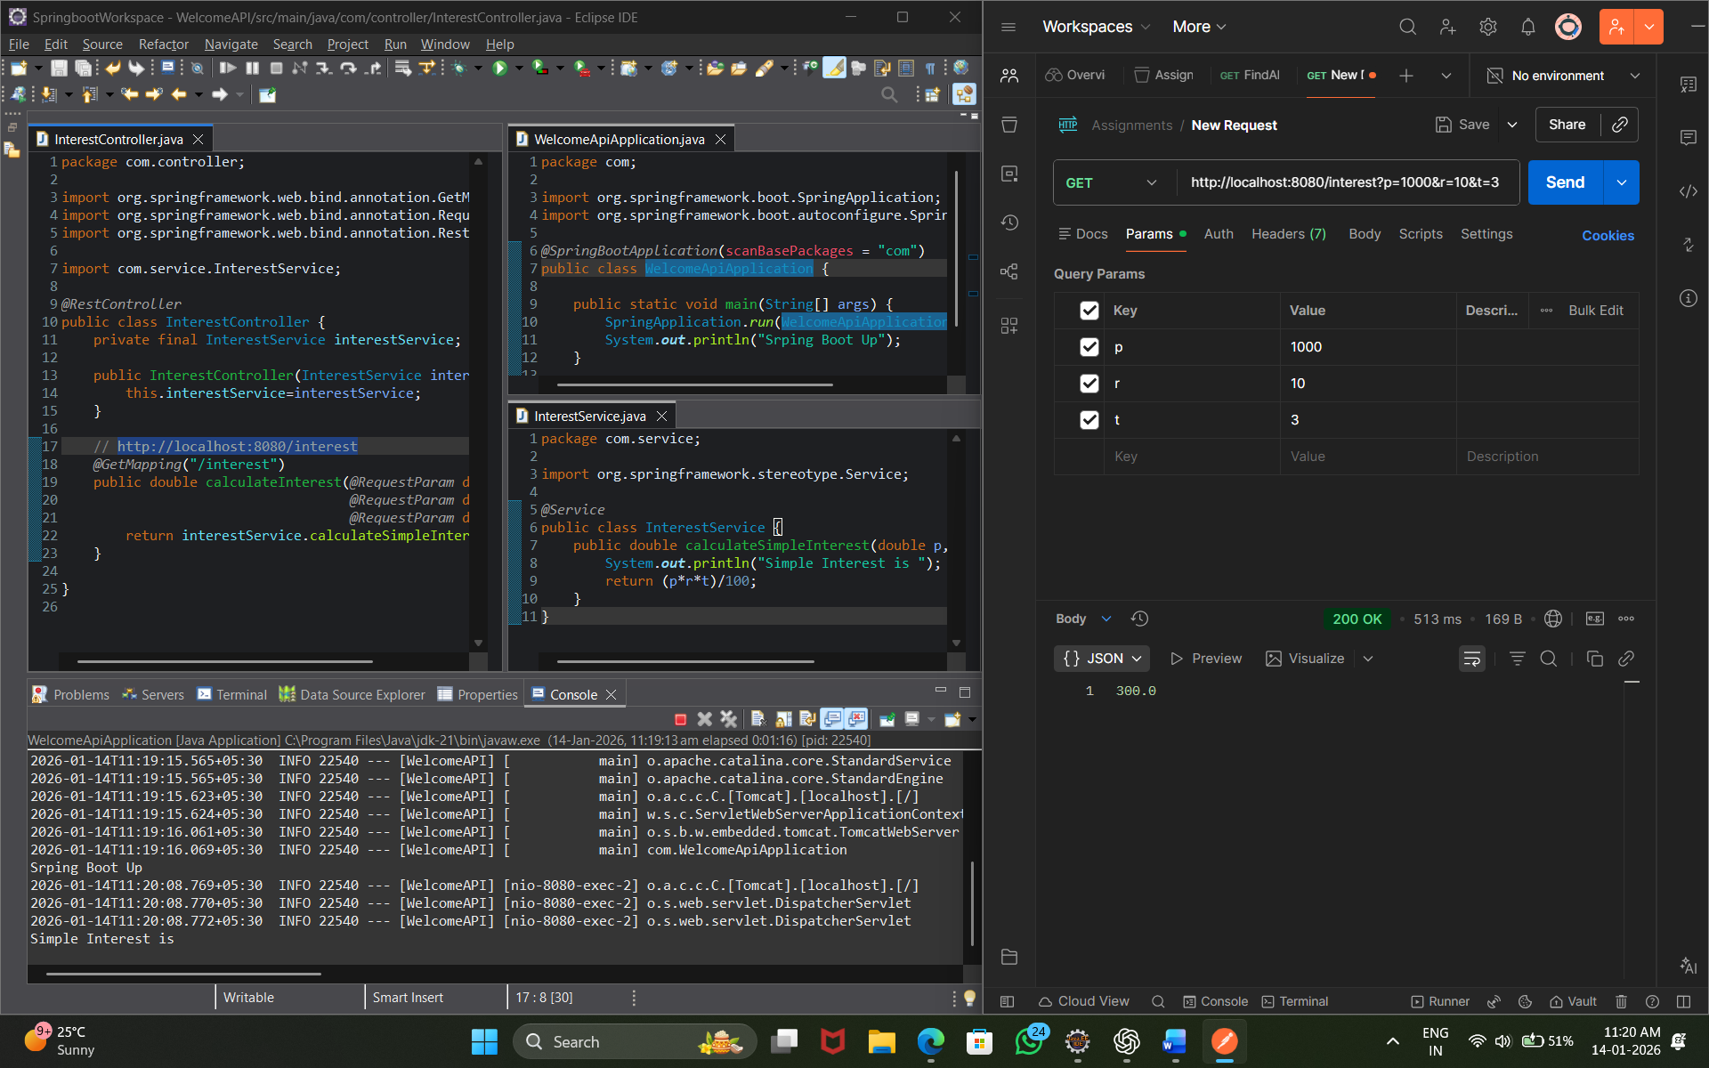

14. Word Count API

Problem Statement: Count number of words in a sentence.

Logic: Split string by spaces.

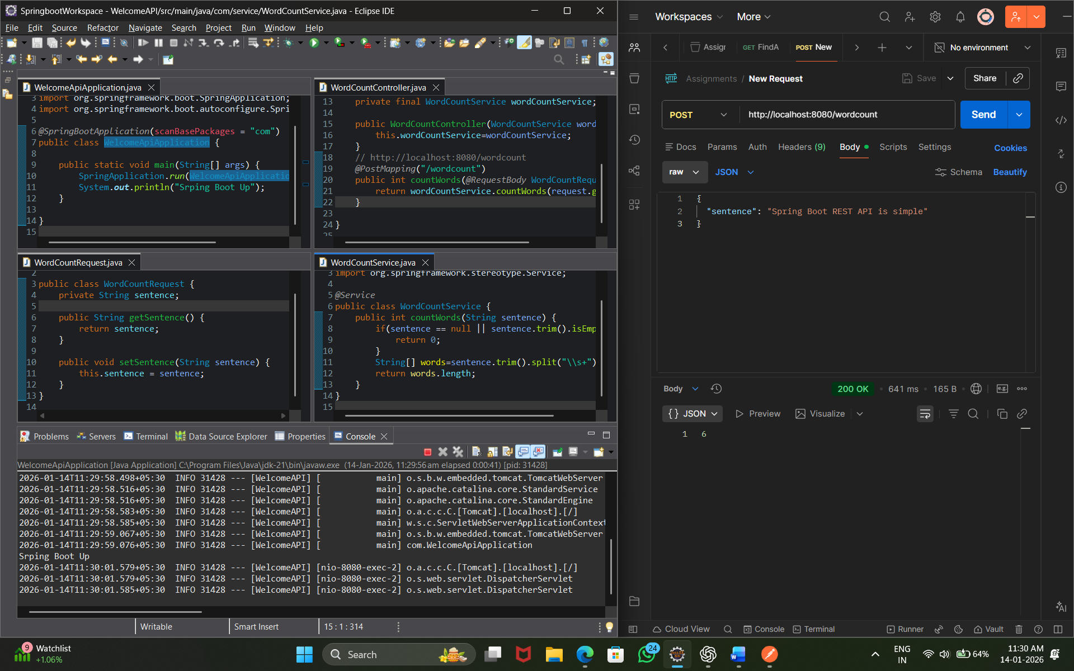

15. Maximum of Three Numbers API

Problem Statement: Find maximum of three numbers.

Logic: Use conditional comparisons.

